**The Footballing Philosophy of**

**Dinnington Town JFC**



**Introduction and Philosophy**

Dinnington Town is a large and growing football club. Between the playing fields at the Dinnington Resource Centre and Dinnington High School we have access to very good quality pitches and a collective commitment to develop these facilities. We have over 130 players and 56 volunteers associated with the junior section at the present time.

With this booklet we hope to provide a clear overview of the Clubs approach to grassroots football, how that fits in with the FA’s initiatives and the vision for the club, its players and also the potential pathway through from *their first experience of playing in organised football* to representing the Town in the first team. In doing that, together we need to provide an environment in which every player will thrive and develop, to play for life at the highest possible standard and also develop into respected adults and football players.

It is also the intention that our DNA will help to keep coaches and parents fully focussed on the single most important thing …………

OUR PLAYERS and THEIR enjoyment of the game!

We want to win, but only in the right way, which is honest and fair. We want this to start with the parents and supporters of players in the junior section who have a huge part to play as the youth teams develop. Without this support these teams will never survive, the club and team management will encourage everyone to take an active part in running the teams and the club. The team managers and coaches are required to attend coaching courses to attain the highest levels. At the time of writing, all of our junior team coaches, as a minimum, are qualified to FA Level 1 standard. The minimum qualification levels are financed through our Club Central Funds (one Level 1 coach per team; where possible we will extend this funding to additional coaches however Central Fund finances are limited.

We are proud to be an FA Charter Standard Community Club, which is the FA’s accreditation scheme available to all grassroots clubs and leagues. This scheme aims to raise standards in the grassroots game,

supporting the development of clubs and leagues, recognising and rewarding commitment, quality and achievement.

In addition to the above, all of our club volunteers are DBS checked and are required to keep this up to date in order to maintain our Charter Standard Community Club status.



**DINNINGTON DNA CODE OF ETHICS**

Now that you have read the Dinnington Town Junior Football Club philosophy we want to ensure that you have fully understood how it operates and how it benefits all involved within our football club.

Below, we have tried to summarise the key points that we feel coaches, players and parents should be fully aware of in order to achieve the aims of our footballing philosophy:

* Every player should be given the time to learn. This can only be achieved with fair and appropriate inclusion within fixtures. ***REMEMBER!*** U7’s to U11’s are purely development focussed age groups. No league tables are produced at this level. And, even though U12’s to U16’s do operate league tables the players are still learning and still evolving into the best footballers they can be. ***Time*** and ***patience*** is vital!
* Every player has a voice. Players are encouraged to have a say in how their team should be run. This is ***their*** game!
* ***RESPECT!*** This is earned, not given! Respect the referees, coaches, players and parents from both teams.
* We are all volunteers at Dinnington Town Football Club. We solely exist to serve our young people within the local community and its surrounding area. Volunteers are the lifeblood of our Club. Without them we would not be able to operate! Wherever you can, please offer your help.
* We are ***not*** a ***“win at all costs”*** club! We want to win, but only in the right way, which is honest and fair.
* Our vision is to create confident, skilful and technical players with the added incentive of one day representing our First Team at senior level.



**Support from Family and Friends**

We cannot stress the importance and overall impact family support has on a player both on and off the pitch.

Players *Play* to have fun, be with their friends, to make new friends, to improve and learn, to feel good, to wear the kit and emulate their heroes.

Players *Quit* due to criticism & yelling, no playing time, over emphasis on winning, pressure, poor communication, fear of making mistakes, boredom or not learning.

Here are a few things we can all do to show our children good sportsmanship, respect and play our part in promoting an environment for player development.

* *Relax and let them play, if you are relaxed the players will be!*
* *Cheer for all the players, including the opponents! Applaud effort, trying new skills and fine play no matter who it is!*
* *Support, don’t coach. Don’t be tempted to give directions during the game. Afterwards, highlight the positives, not the mistakes!*
* *Thank the coaches and officials after the game – win, lose or draw!*
* *Support the clubs development of players and have reasonable expectations as well as keeping any strong emotions in check!*

*Try and have fun, that’s what the players are trying to do!*

**Evolution of Football**

The game is rapidly evolving! The FA’s Future Game released in 2015 sets out a blueprint for youth player development at all levels of the game. Football is no longer played at 11v11 across all age ranges –

Mini-Soccer has evolved into the following categories:

5v5 at Under 7s and 8s,

7v7 at Under 9s and 10s,

9v9 at Under 11s and 12s

This ensures that children are playing on appropriate sized pitches with appropriated sized goals and most importantly appropriately sized footballs! At Dinnington Town we class these age groups as Learning Phases 1 & 2.

Sheffield & District Junior Sunday Football League operates ‘development focussed’ games at U7’s up to and including U11’s. These playing seasons are currently split into a maximum of 3 terms with the potential for each term to end with a cup competition format. These age groups do not operate league tables, although results are still submitted and collated in order to determine similar ability divisions throughout the course of the respective season. The emphasis here is for the players to purely play and enjoy their football without the added pressures of accruing points, promotion and relegation, etc.



With fewer players playing on smaller pitches, this allows for more touches per player per game, helping develop greater technical skills at the youngest age, when learning comes naturally.

Another really important point to note at these early years is the option of operating as a single or double team. Up to and including U10’s, these teams may operate as either. However, at the time of writing, U11’s and onwards may only operate as a single team. This doesn’t mean that Dinnington Town will not support additional teams at the same age group, but what it does mean is that unfortunately a natural team split will need to take place in order for this to be fulfilled. This can be a difficult moment in time for all involved but support is available in order to make this as stress free as possible for all concerned. Frustratingly, as U11’s & U12’s still operate as mini soccer teams, once U13’s are reached the need to acquire more players becomes a factor. It is hoped that with a collective, thoughtful and diplomatic approach to team splitting at U10’s there will be a large

enough pool of players within the club for many of these players to be reunited at U13’s and continue onwards to the adult game.

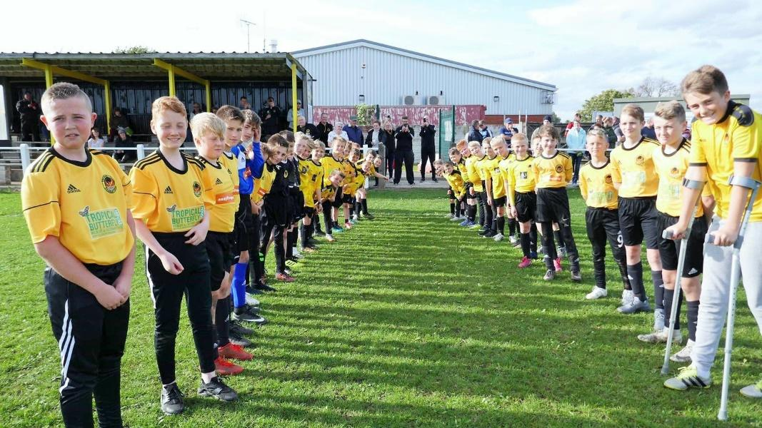

**TECHNICAL: Ball mastery, practice and group play**

Dinnington’s philosophy gives our players both training and competitive matches in a calm, safe environment, free from adult criticism, to practice and try out their ball skills and group play. Futsal, where available, accelerates it further and faster. By the time they reach 11 a-side football at Under 13’s, our players have already played over 100 matches!

**Practice makes perfect!**

**PSYCHOLOGICAL: Understanding, decision making, confidence**

Dinnington’s philosophy is to give players time and space to think and make decisions, without a wall of adult noise and pressure. Every mistake is a learning opportunity. Equal time on the pitch in mixed ability teams grows confidence and leadership skills.

**Mistakes accelerate learning!**

**PHYSICAL: Co-ordination, conditioning, challenge**

Dinnington’s philosophy doesn't just give players full-on fitness sessions, the fast-moving play accelerates their ABC motor skills: agility, balance and co-ordination. The level of physical challenge, from sprinting to be first to the ball to being brave in challenging for it grows their physical abilities and confidence.

**Equal teams means more competition!**

**SOCIAL: Communication, self-esteem, teamwork**

Dinnington’s philosophy develops players' communication skills from U7, when they are very self-focused, through a greater understanding of group play from U9 to a focus on team play at U11 and beyond. Our positive environment, equal teams and equal time on the pitch rules really build their self-esteem.

**Children learn more by playing than watching!**

**Player Development**

Dinnington Town coaches are committed to put the player at the centre of everything we do and development is the *number 1 priority*. This is in line with the FA’s strategy for long term development for players from grassroots and upwards. The FA’s model is referred to as the *4 Corners* which outlines the range of influencing factors that need to be considered in order for young players to reach their full potential.

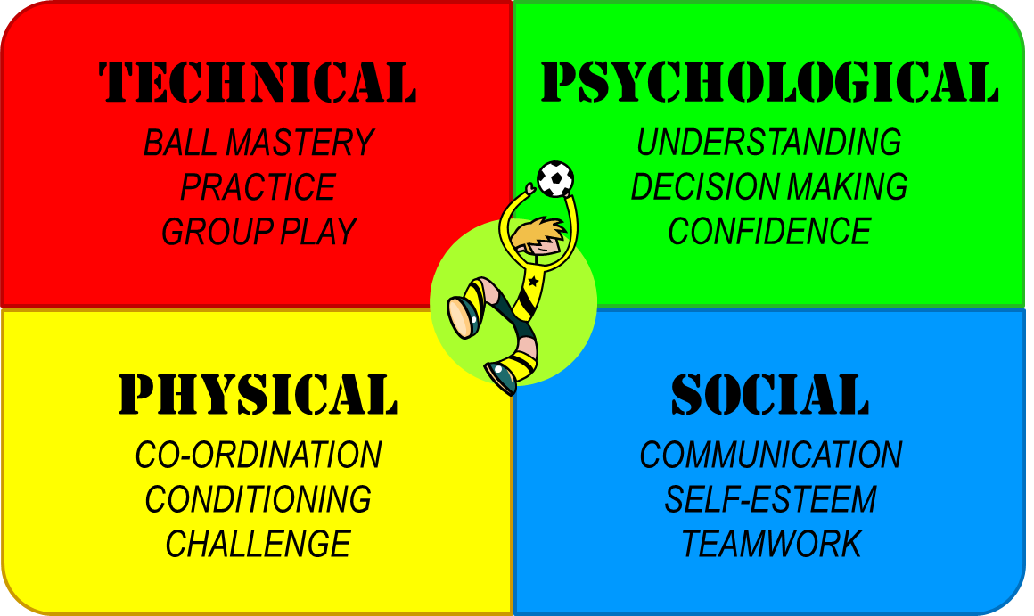

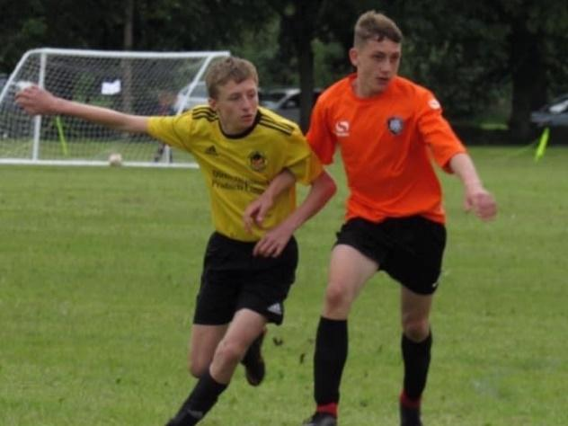 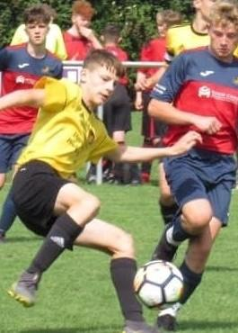

From U13’s to U16’s the League operate a full season of competitive divisions at 11v11, right through to senior level. The significant difference is ball, pitch and goal size are still not full size as regularly seen at adult level (size 5 balls are introduced at U15’s). However, emphasis is still very much geared towards development of the players as I am sure you will agree they are still not yet the ‘finished article’ by any stretch of the imagination. We class these age groups as Learning Phases 3 & 4.

By using progressive coaching methods, Dinnington are committed to help every player develop to the best of their ability and enjoy learning as they go as well as in a respectful, sporting manner.

It cannot be emphasised enough that all children grow and learn the game at different rates. Some children will grasp concepts straight away and will grow physically quicker. Others will take longer to understand how the game is played and may take several years to physically grow and gain confidence. The important message to take from this is that **time** and **patience** is a massive factor with individual player development.

The impact of this could be that Dinnington needs to run more than one team in an age group and we would need additional support for the incumbent manager in those circumstances.

Dinnington recognise that players only develop when allowed to play and as such managers and coaches aim to provide football for all and to give players half a game as long as it’s in the player’s best interests, as its clear players don’t develop by sitting on the bench. Again this suggests it may be necessary to have more than one team in an age group to accommodate the numbers and organise such that players continue to develop.

We aim to have a Club full of confident, able young footballers who enjoy playing an exciting brand of football without fear of failure.

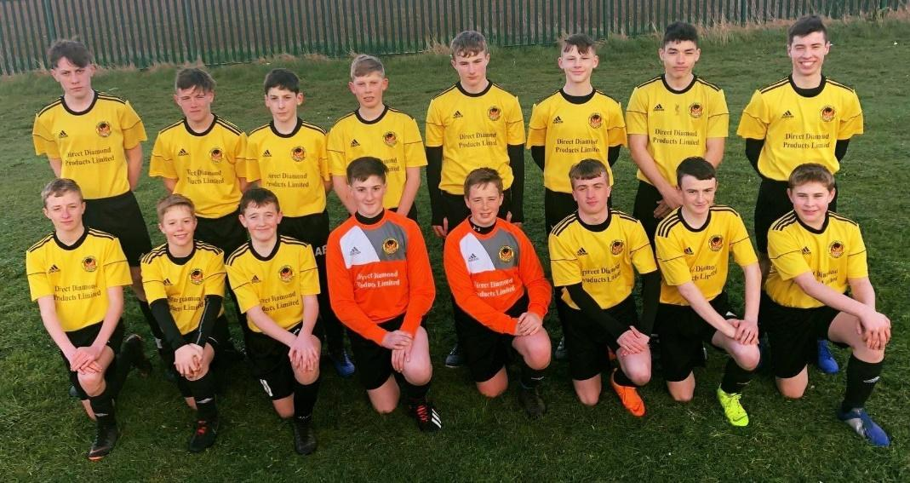

Dinnington coaches have the following vision of a player:

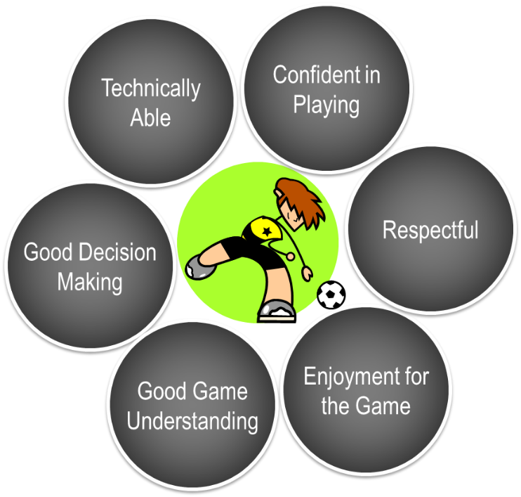

We have identified the phases of a player’s and team’s development and strive as coaches to hold sessions which focus on the appropriate phase and using game related sessions as much as possible to challenge the players to their maximum. It is worth noting that the final two phases are only applicable at the later years of the 11 a-side game and the final phase only in preparation for the senior teams.



**Phase 1 Phase 2 Phase 3 Phase 4**

**Important Club Contacts**

***Club Officials***

Chairman Andy Marshall 07870 559454 [andymarshalluto@gmail.com](mailto:andymarshalluto@gmail.com)

Vice Chairman Rob Cully 07515 822712 [robertcully@gmail.com](mailto:robertcully@gmail.com)

Secretary Katie Curtis 07970 426605 [s.curtiss@btinternet.com](mailto:s.curtiss@btinternet.com)

Treasurer Paul Gregory 07887 748524 [pgregory23@outlook.com](mailto:pgregory23@outlook.com)

Welfare Officer Rachel Marshall 07932 958080 [rachelmarshall80@hotmail.co.uk](mailto:rachelmarshall80@hotmail.co.uk)

Committee Mick Godber 07909 961244 [mrl.godber@hotmail.com](mailto:mrl.godber@hotmail.com)

Committee Paul Jones 07730 530409 anstonowl@gmail.com

Committee Nick Lockerbie 07597527619 nicholas1787lockerbie@hotmail.com

Committee Matt Cox 07368686313 cox1889@hotmail.co.uk

Committee Mark Storey 07815 464382 StoreyM@dewarenne.org.uk

Committee Lee Brown 07720575396 leebrown99@hotmail.com

***Team Managers***

|  |  |  |
| --- | --- | --- |
| Nursery | Andy Marshall | 07870 559454 |
| U7’s | Ian Couldwell | 07743450480 |
| U7’s Blacks | Richard Johnson | 07824808413 |
| U8’s | Nick Lockerbie | 07597527619 |
| U8’s Blacks | Sean Evans | 07927347173 |
| U8’s Girls | Chris Allen | 07802828071 |
| U9’s | Matt Cox | 07368686313 |
| U10’s | Ben Birks | 07590379373 |
| U11’s Girls | Claire Burton | 07968 344727 |
| U11’s | Andy Cawthorne | 07855 774338 |
| U12’s | Mark Storey | 07815 464382 |
| U13’s | Ryan Taylor | 07446 155890 |
| U14’s | Andy Marshall | 07870 559454 |
| U15’s | Paul Gregory | 07887 748524 |
| U16’s | James Hill | 07805 061652 |
| U17’s | Matt Orton | 07940 805528 |
| U21’s | Craig Denton | 07504663906 |
| Reserves | Darren Roe | 07504546221 |
| 1st Team | Gary Eades | 07919 990511 |
| Over 45's | Sammy Palmer | 07941857761 |

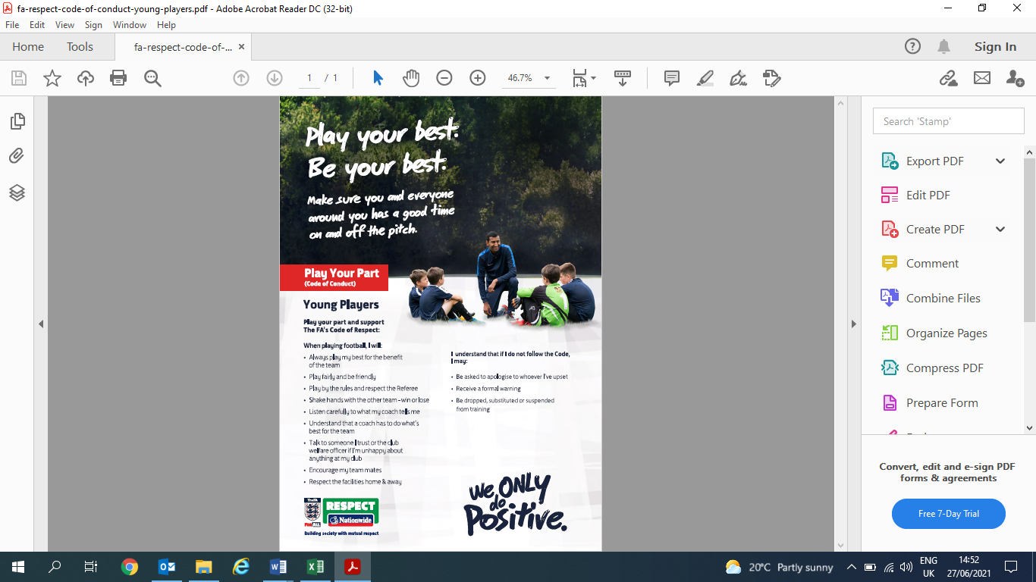



**Updated: July 2022**